Peninsula Playcentre Playgroup
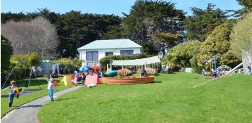
Learning through fun and play
for 0-6 year olds and their whanau.

Mondays and Wednesdays 9.30am – 12.30pm
30 Harrington Point Road, Portobello.
(next to Portobello School pool)
peninsula@playcentre.org.nz

find us on facebook @peninsulaplaycentre

